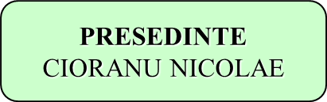

**BIROU CENTRAL R.G.**

**COMISIE TEHNICA**

* DAGAU ANDREA

coord. tehnic

* HORVATH STEFAN

resp R.G. Si C.Z.

* CSIZMADIA BIANCA
* POPA ANDREA
* CHIRUTA EDUARD

**CONSILIUL TEHNIC**:

*HORIA GROSU*

*VOIA SORIN*

*PASCAL CONSTANTIN*

*BALTEAN VALENTIN*

*IONICA NECHIFOR*

*CSIZMADIA STEFAN*

**CONSILIUL DIRECTOR**:

*STANCA DUMITRU*

*DOBROTA ION*

*DOBROTA MITICA*

*DANULETIU NICOLAE*

*OPREAN IOAN*

*VONICA CONSTANTIN*

**BIROU REGIONAL 2**

ISDRARIU IONUT

**DEPARTAMENT FINANCIAR:**

*NEAGU MARIANA*

**DEPARTAMENT JURIDIC:**

*AVOCAT MIOARA VADUVA*

**BIROU REGIONAL 1**

CSIZMADIA STEFAN

**BIROU REGINAL 3**

CRACIUN IOAN

**TM,CS,AR,BH, SM, SJ, CJ, HR, MS, MM**

**GJ, HD, VL, AG, SB, AB,CT**

**BN, SV, NT, BC, VN, BT, IS, VS, IL**

* Legenda:

Rol consultativ

Rol de subordonare

Rol de colaborare

Rol decizional

ORGANIGRAMA